## Developing with the Power BI Service API

**Setup Time**: 60 minutes

**Lab Folder**: C:\Student\Modules\07_PowerBiServiceApi\Lab

**Overview**: In this lab, you will log into an Azure AD user account that has been created for you in an Azure AD tenant shared by all students which has a domain name of **powerbimvps.onmicrosoft.com**. Once you have logged into the Power BI service and started your 60 Power BI Pro trial, you will be able to upload PBIX files into your personal workspace and you can begin designing dashboard and reports in the browser. The lab will also step you through downloading and installing Power BI Desktop as well as publishing a Power BI Desktop project to the Power BI service. You create a new app workspace and populate it with a dataset, a report and a dashboard. In the final exercises, you will program against the Power BI Service API.

### Exercise 1: Create a New App Workspace to Build a Custom Solution

In this exercise, you will create a new app workspace. After that, you will populate the workspace with datasets, reports and a dashboard just as you did in your personal workspace.

1. Create a new app workspace.
   1. Expand the Workspace menu in the left navigation and select the **Create app workspace** command.

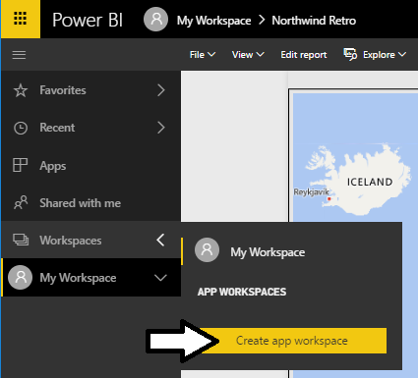

* 1. Enter your name into the **PBIS API Lab** textbox.
  2. Add your user account as a workspace member with **Admin** permissions.
  3. Click **Save** to create the new app workspace.

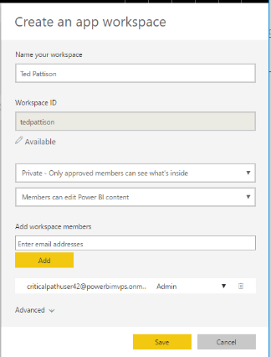

* 1. Power BI should create the new app workspace and navigate you to its welcome page as shown in the following screenshot.

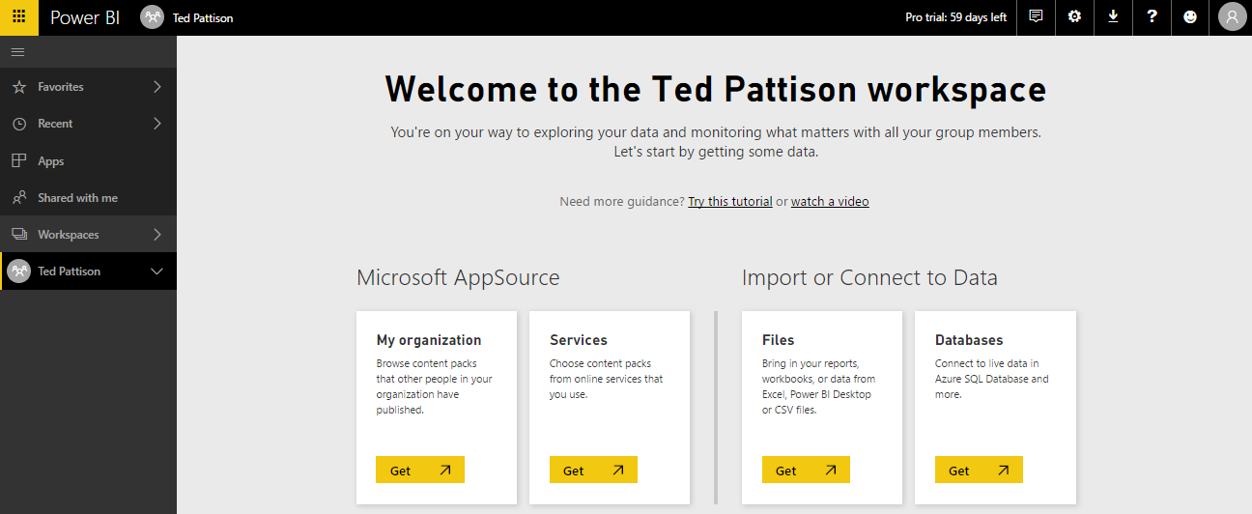

* 1. If you expand the **Workspaces** menu in the left navigation, you can see it provides the Ability to move between your personal workspace and any available app workspace.

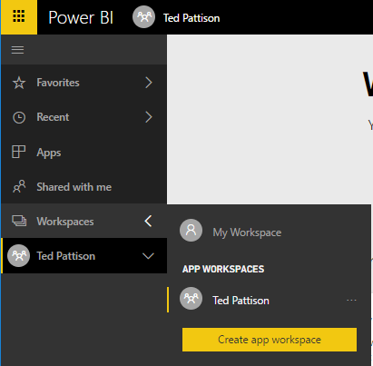

* 1. Navigate you’re your personal workspace.
  2. Now, navigate back to your new App Workspace.

1. Add content to your new app workspace.
   1. On the Welcome page of the app workspace, click the **Get** button in the **Files** section.

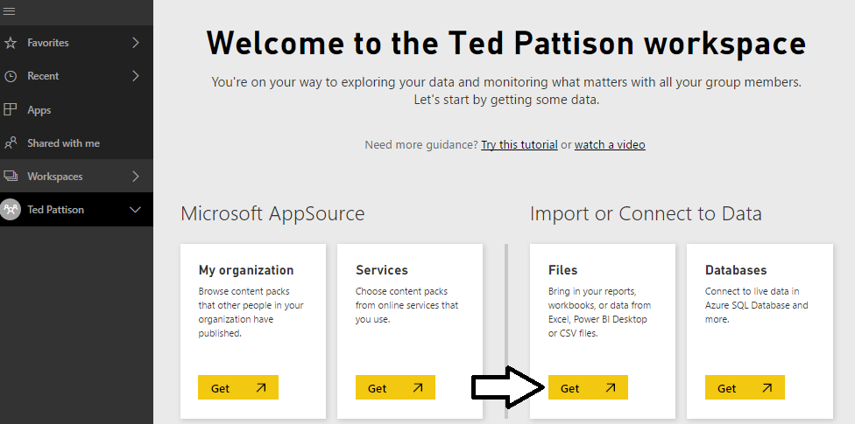

* 1. On the next page you should see several tiles which indicate your choices for the location of the file you would like to connect to or import. Click on the tile with the caption **Local File** and import **Northwind Retro.pbix** from inside your student folder.

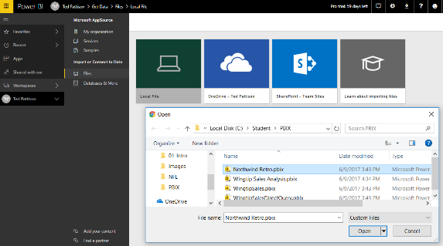

* 1. Repeat the previous step to import the other PBIX project file named **Wingtip Sales Analysis.pbix**.
  2. You should be able to verify that your app workspace now contains two datasets.

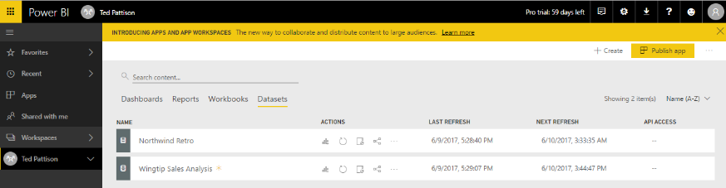

* 1. Delete any dashboard that was created when your imported the two PBIX project files.

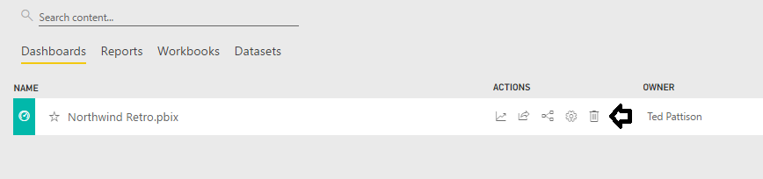

* 1. Switch to **Reports** view and open the report named **Wingtip Sales Analysis**.

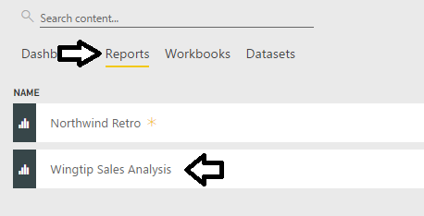

* 1. Just as you did back in lab exercise 3, create a new dashboard named **Wingtip Sales Analysis** by pinning visuals from the report named **Wingtip Sales Analysis**.

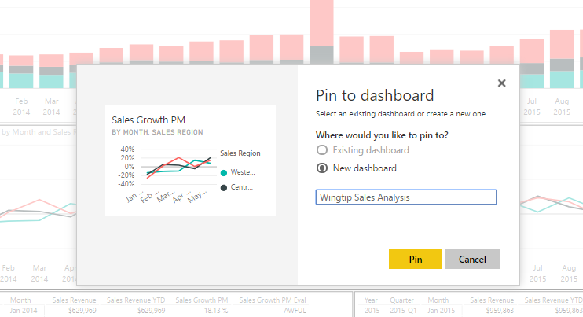

* 1. Add several titles to the dashboard until it resembles the dashboard shown in the following screenshot.

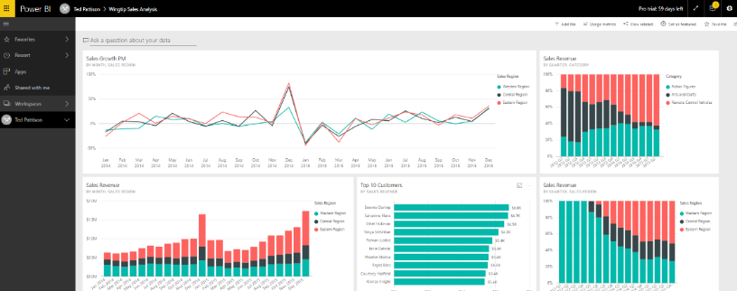

### Exercise 2: Publish a Project with Power BI Desktop

In this lab exercise you will open and publish a PBIX project using Power BI Desktop. Keep in mind that neither this lab nor this workshop has been designed to teach you much about the details involved with designing queries and building data models with Power BI Desktop. It’s assumed that you already have these skills or you will learn how to design datasets and reports with Power BI Desktop outside of this workshop. The purpose of this lab exercise is for you to see how the publish datasets and reports created with Power BI Desktop into workspaces running in the Power BI service.

1. Launch Power BI Desktop if it’s not already running.
2. Open the PBIX project file named **Northwind Retro.pbix**.
   1. Select the **File > Open** command.

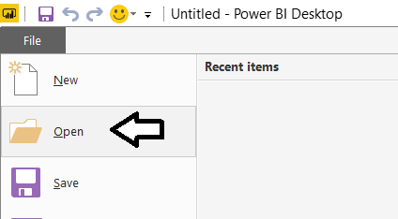

* 1. In the **Open** dialog, navigate to the folder at **C:\Student\PBIX** and double-click **Northwind Retro.pbix**.

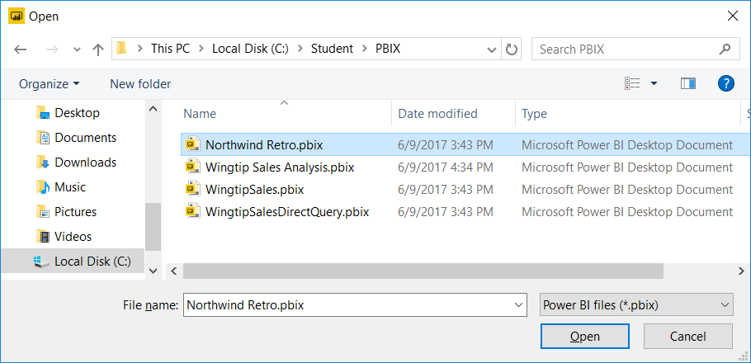

1. Review the contents of the **Northwind Retro** project.
   1. When the **Northwind Retro.pbix** project opens, Power BI Desktop displays it in Report view.

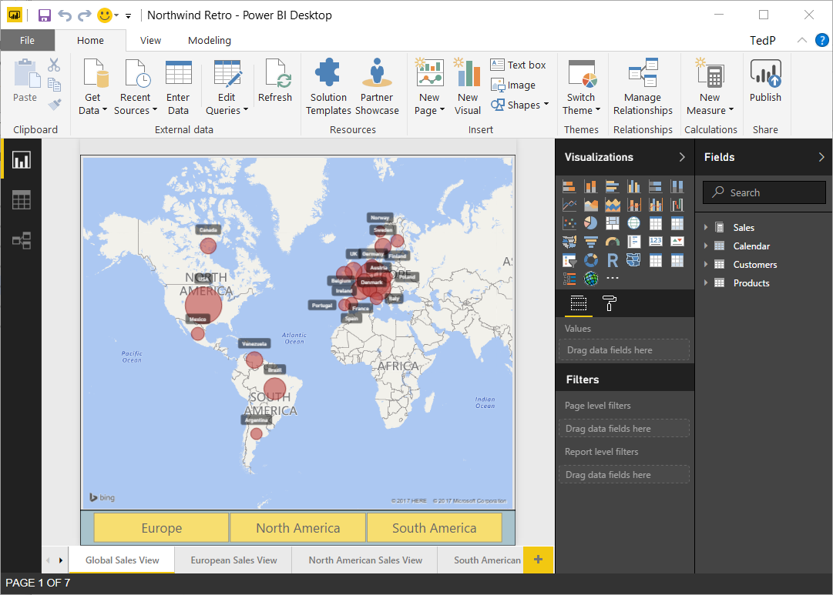

* 1. Inspect all the pages in the report by navigating using the tabbed page navigation at the bottom of the report.
  2. Locate the **Fields** list on the right-hand side of Report view in the main Power BI Desktop window.
  3. You should see four tables named **Sales**, **Calendar**, **Customers** and **Products**.



* 1. Expand each of the tables to in the **Fields** list to see what fields are inside each table.

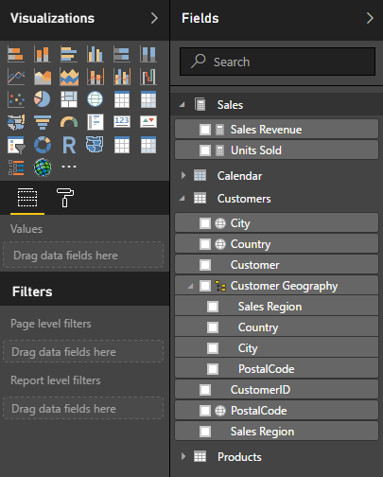

* 1. Switch the project into **Data view** and inspect the data in each of the four tables.

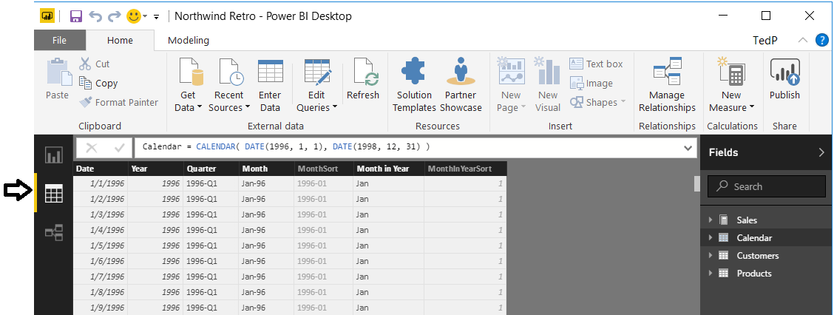

* 1. Switch the project into **Relationship view** to get a high-level picture of the project’s data model.

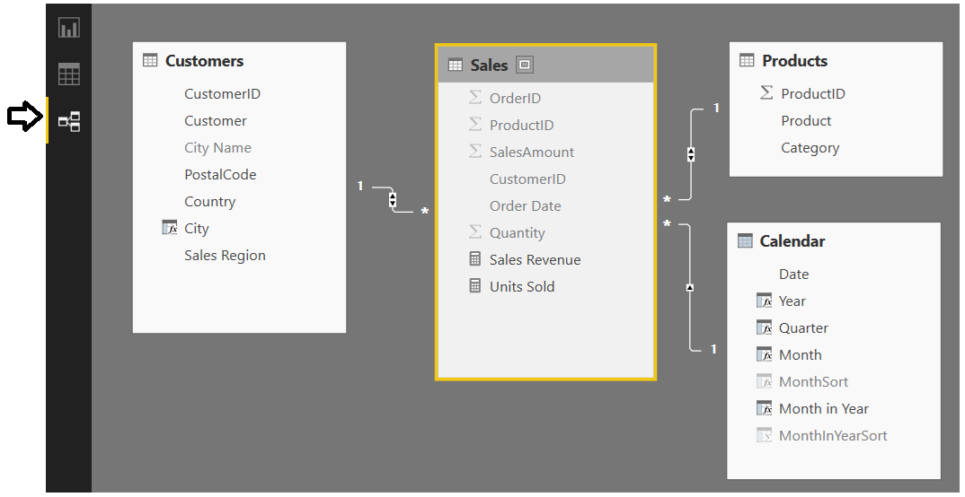

Now it’s time to look at the queries in the project that were used to import the base tables into the project’s data model.

* 1. On the **Home** tab in the ribbon, select the **Edit Queries** command to open the Query Editor window.

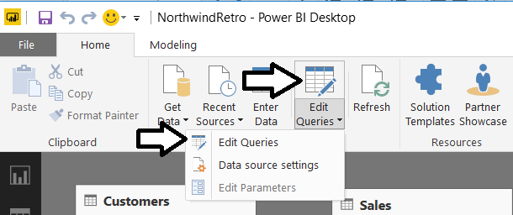

* 1. In the Query Editor window, examine the queries listed in the **Queries** list on the left.

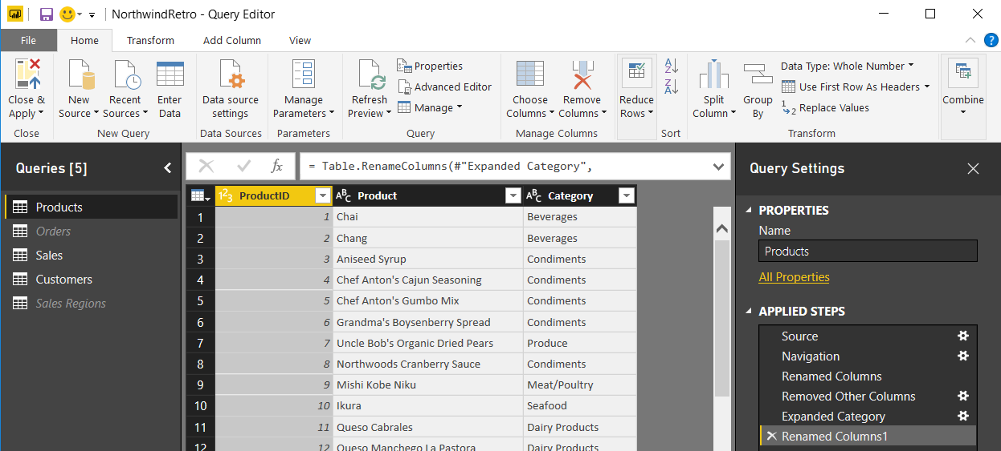

* 1. Select the **Close and Apply** command in the ribbon to close the **Query Editor** window.

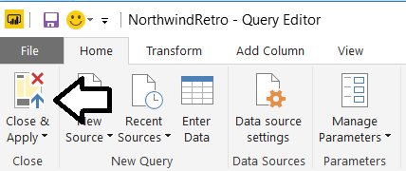

* 1. If you have made any changes to the project, click the **Save** button above the ribbon to save your work.

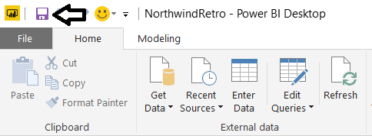

1. Publish the **Northwind Retro** project to your personal workspace in the Power BI service.
   1. On the **Home** tab in the ribbon, click the **Publish** button.

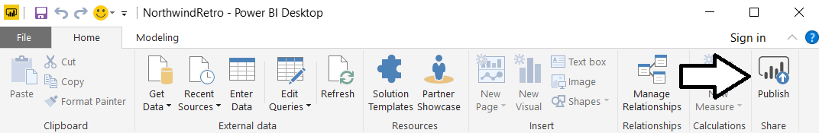

* 1. When prompted to sign in, enter the name of your Power BI user account and click the **Sign in** button.

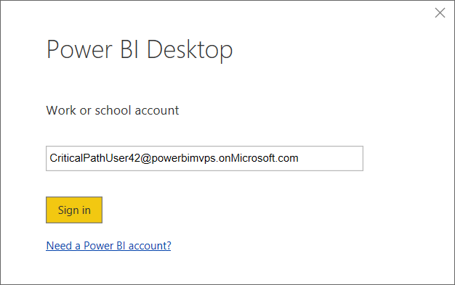

* 1. Power BI when prompted, enter your password and click **Sign in**.

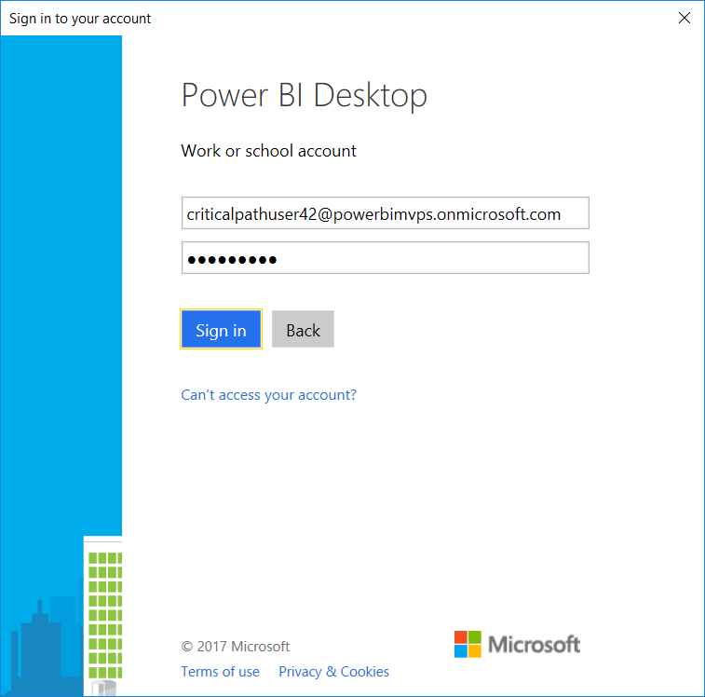

* 1. Wait until you see the notification indicating that the project has been published successfully.

1. Examine what’s been added to your personal workspace in the Power BI service.
   1. Return to the Power BI Service in the browser and verify a new dataset has been created.

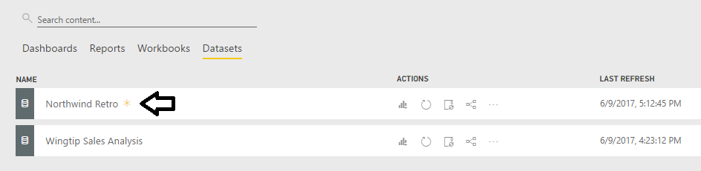

* 1. Navigate to the Reports list and click on the report named **Northwind Retro** to open it.

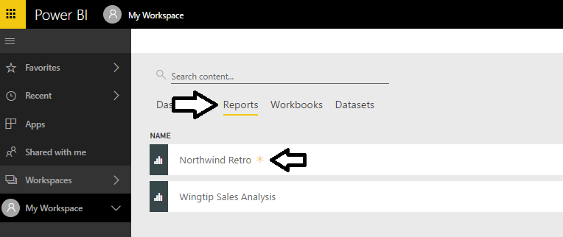

* 1. Take a moment to interact with the report in the browser.

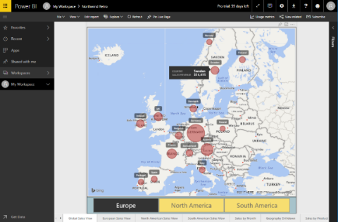

Now you have seen several different techniques for adding content into a Power BI workspace. In the next exercise, you will create a app workspace and then populate it with content. As you will see, adding datasets, reports and dashboards to an app workspace is very similar to adding content to a personal workspace. The big difference is that app workspaces have advantages over personal workspaces such as support for team-based development and app distribution as well as Power BI Premium support for making embedded reports accessible to non-licensed users.

### Exercise 3: Register a New Application with Azure Active Directory

In this exercise, you will register a new application with Azure AD and you will configure the application’s required permissions to access the Power BI Service API.

1. Log into the Azure Portal
   1. In the browser, navigate to the Azure portal at <https://portal.azure.com>.
   2. When you are prompted to log in, provide the credentials to log in with your Office 365 user account name.
   3. If you are prompted to start a tour of Microsoft Azure, click **Maybe later**.

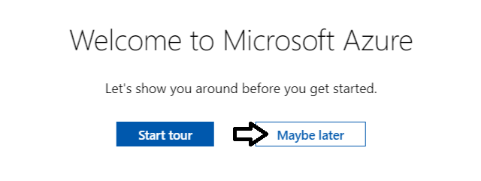

* 1. Once you are log into the Azure portal, check the email address in the login menu in the upper right to make sure you are logged in the Azure portal with the correct identity.

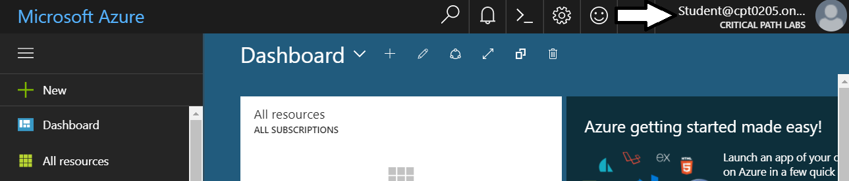

1. Register a new Azure application.
   1. In the left navigation, scroll down and click on the link for **Azure Active Directory**.

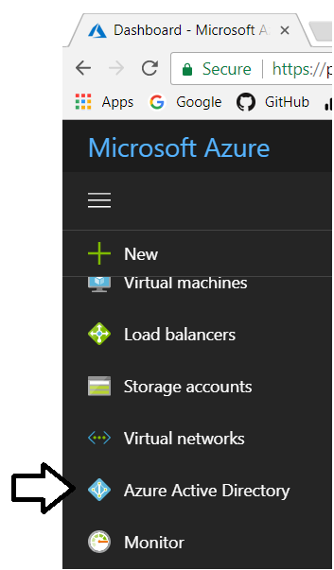

* 1. Click the link for **App registration**.

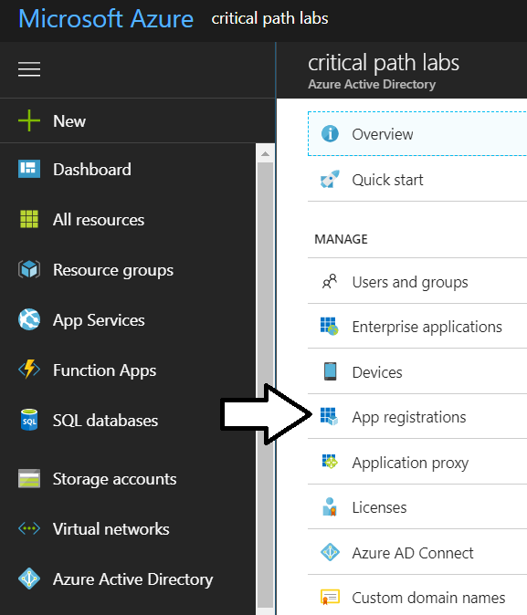

* 1. Click **New application registration**.

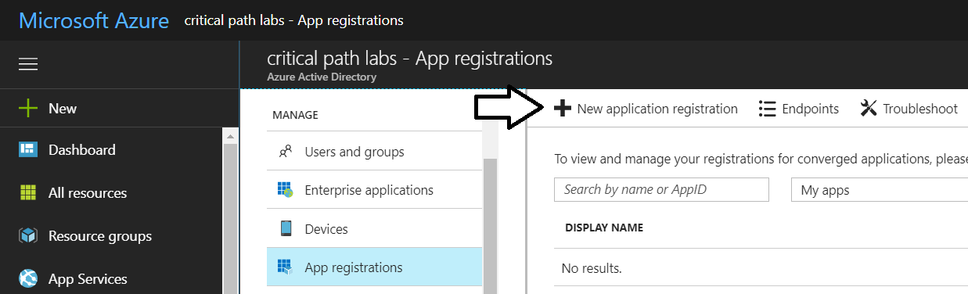

* 1. In the Create dialog…
     1. Add a **Name** of **My Azure App**.
     2. Set the **Application type** to **Native**.
     3. Set the **Redirect URI** to <http://localhost/app1234>.
     4. Click the **Create** button to create the new application.

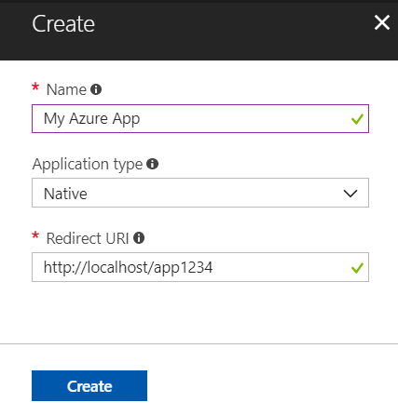

* 1. Once should now see the new application.

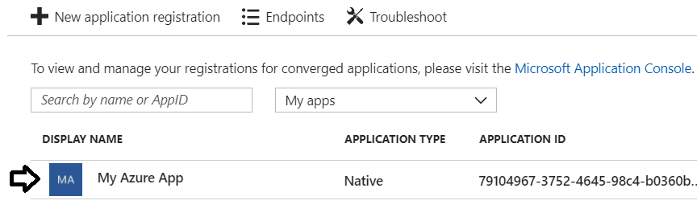

1. Copy the GUID for the Application ID.
   1. Click on the link for the new application named **My Azure App** to get to the details page.

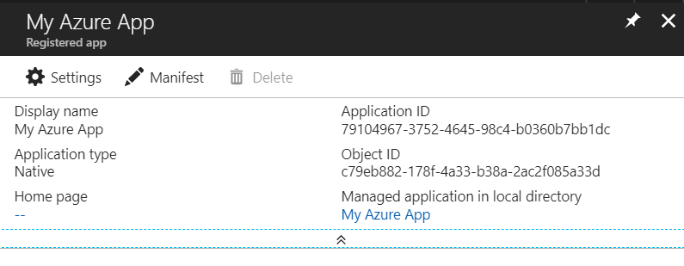

* 1. Copy the Application ID to the Windows clipboard.

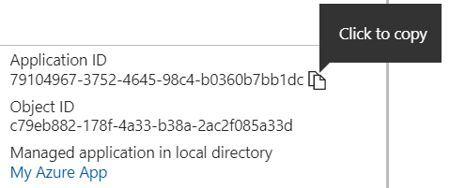

* 1. Launch Notepad and paste the Application ID into a new document. Also add the value of the Redirect URI.

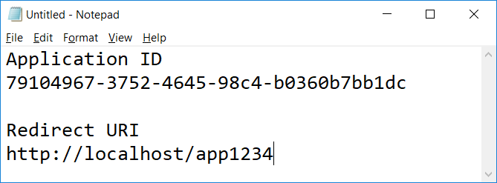

* 1. Click on the **Settings** link to configure application settings,

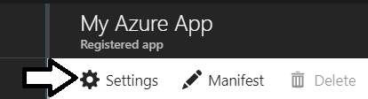

* 1. Click **Required permissions**.

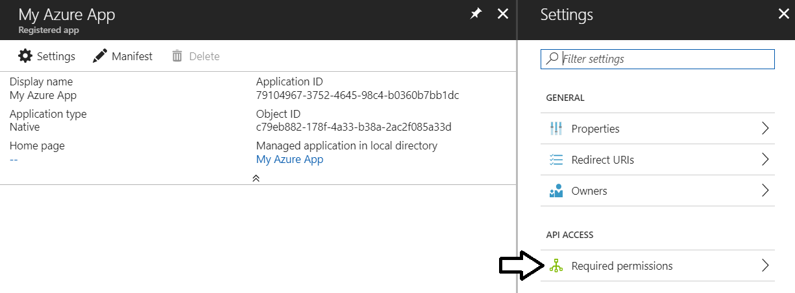

* 1. Click the **Add** button on the **Required permissions** blade.

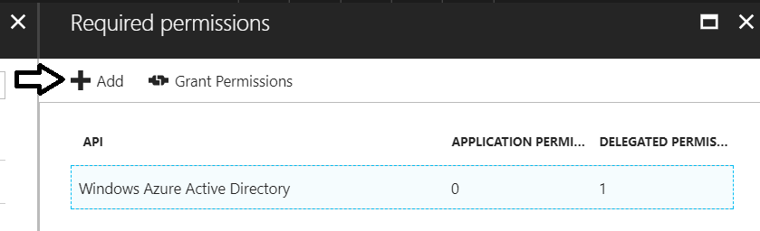

* 1. Click the **Select an API** option in the **Add API** access blade.

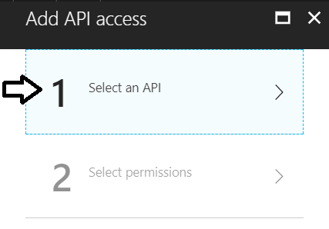

* 1. In the **Select an API** blade, click **Power BI Service**.

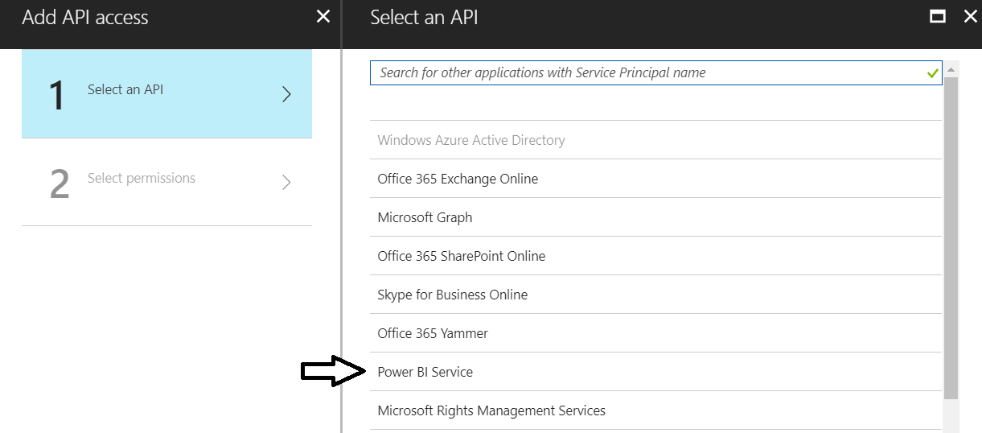

* 1. In the **Enable Access** blade, click the top checkbox for **DELEGATED PERMISSIONS** to select all the permissions.
  2. Once you have selected all the permissions, click the **Select** button at the bottom of the blade.

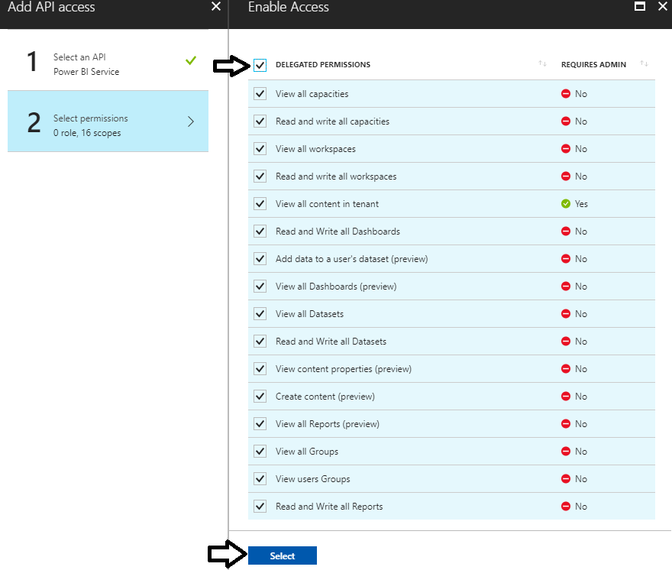

* 1. Click the **Done** button at the bottom of the **Add API Access** blade.

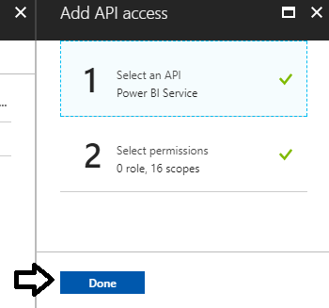

* 1. At this point, you should be able to verify that the Power BI Service has been added to the **Required permissions** list.

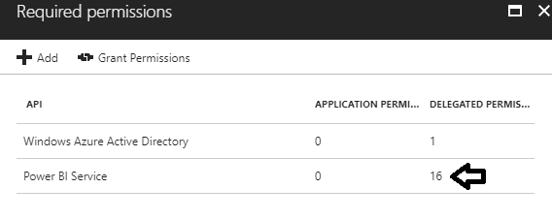

You are now done registering your application with Azure AD.

### Exercise 4: Create a New C# Console Application

In this exercise, you will create a simple C# Console application to call into the Power BI Service API.

1. Create a new C# Console application in Visual Studio.
   1. Launch Visual Studio.
   2. Create a new project by running the **File > New Project** command.
   3. Select a project type of Console App from the Visual C# project templates.
   4. Give the project a name of **HelloPowerBiApi** and click OK.

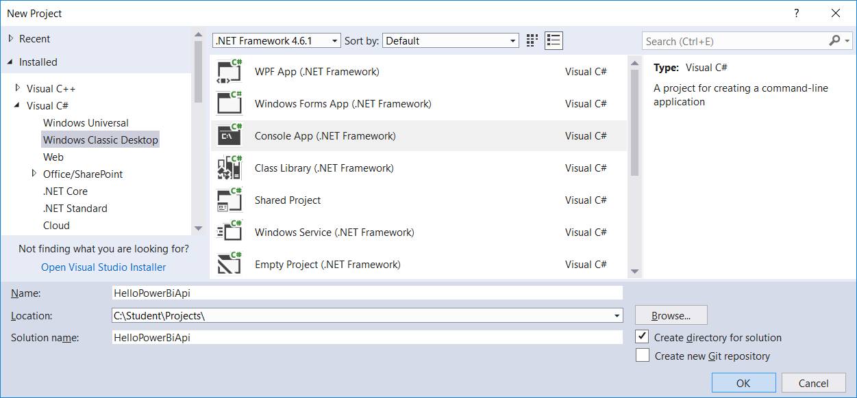

* 1. You should now have a new project named **HelloPowerBiApi**.

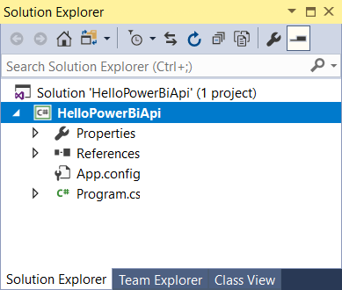

1. Add NuGet package to the project.
   1. Right-click the top-level node for the **HelloPowerBiApi** project and select **Manage NuGet Packages…**.

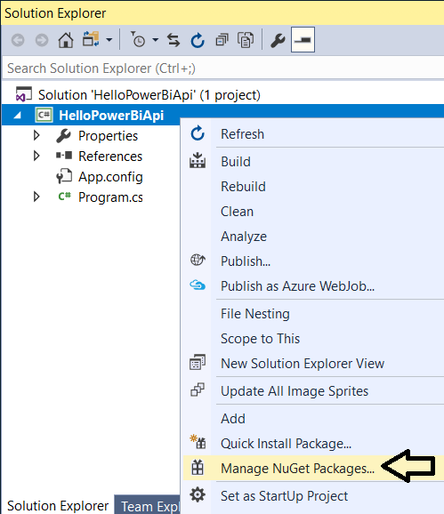

* 1. Click the Browse tab and type ADAL into the search box.
  2. Locate the package **Microsoft.IdentityModel.Clients.ActiveDirectory**. This is the Active Directly Authentication library.

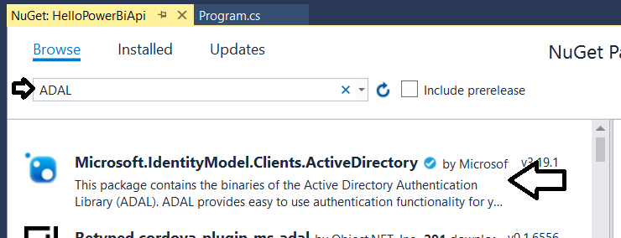

* 1. Select and install **Microsoft.IdentityModel.Clients.ActiveDirectory**.

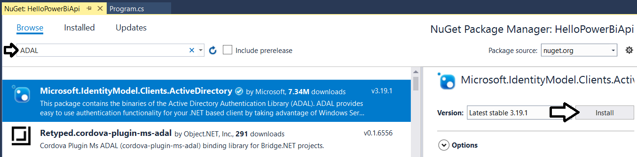

* 1. When prompted about the licensing agreement, click **I Agree**.
  2. Search for Power BI and then find and install the **Microsoft.PowerBI.Api**.

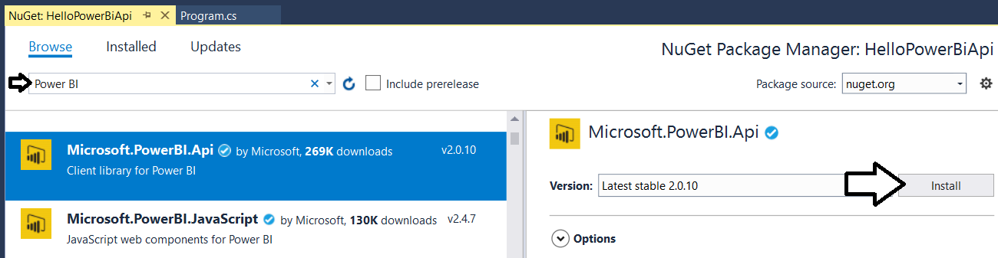

* 1. When prompted about the licensing agreement, click **I Agree**.

1. Update all NuGet packages.
   1. Navigate to the **Update** tab and update any packages that have updates available.

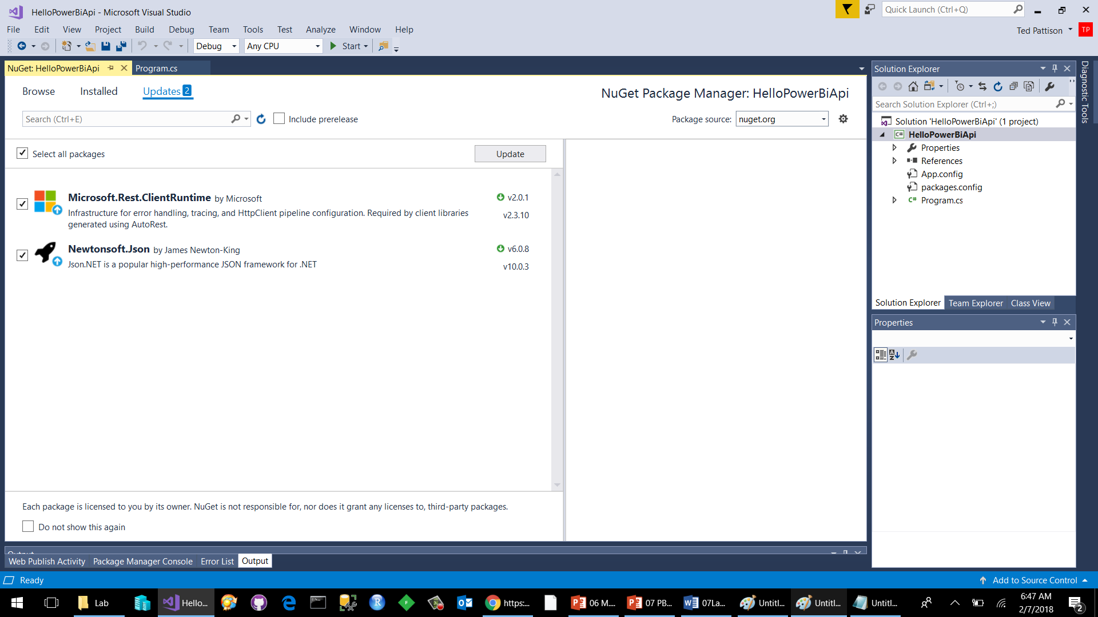

* 1. Close the window for the Nuget Package Manager.

1. Add code to the project
   1. Using Windows Explorer, locate the file named **PowerBiStarter.cs.txt** located in the Student folder at the following path.
   2. Open the file named **PowerBiStarter.cs.txt** in Notepad and copy its contents into the Window clipboard.
   3. Return to the **HelloPowerBiApi** project in Visual Studio.
   4. Open the source file named **program.cs**.
   5. Delete all the code inside **program.cs** and replace it with the content you copied into the Windows clipboard.
   6. You should now have the basic code for a simple application which access the Power BI Service API.

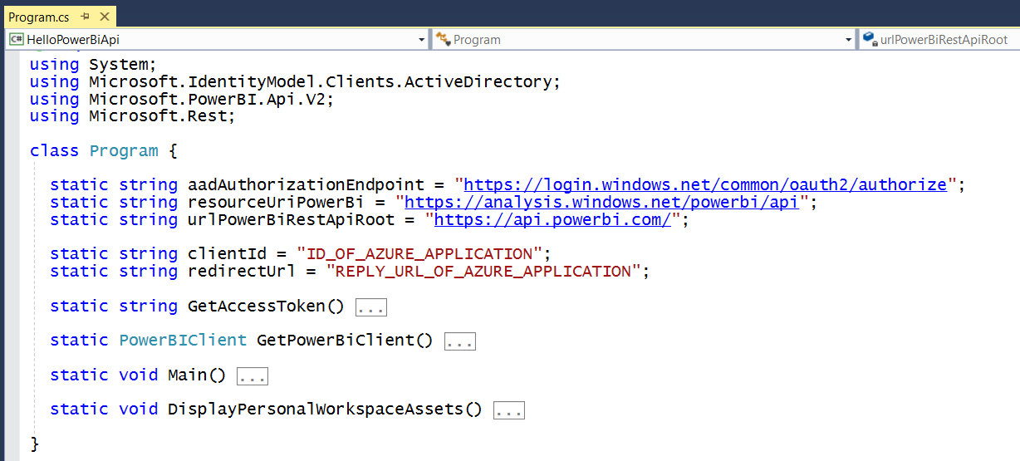

1. Update the code with your Application ID and Redirect URI.
   1. Locate the section of the code with the static properties named **clientId** and **redirectUrl**.



* 1. Replace these values with the values you copied into Notepad earlier.



* 1. Save your changes to **program.cs**.

1. Run the application to call to the Power BI Service API.
   1. Press the {F5} key to begin a debugging session.
   2. When promoted to sign in, log in using your Power BI account and credentials.

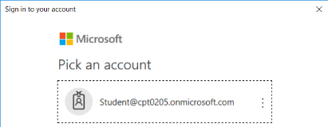

* 1. When prompted with the following screen, click **Accept**.

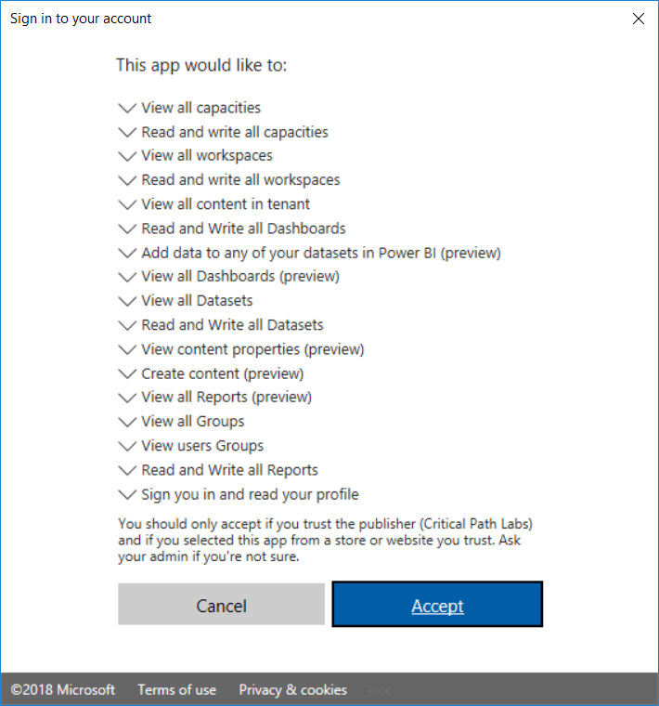

* 1. The application should call into the Power BI Service API and retrieve data about the contents of your personal workspace.

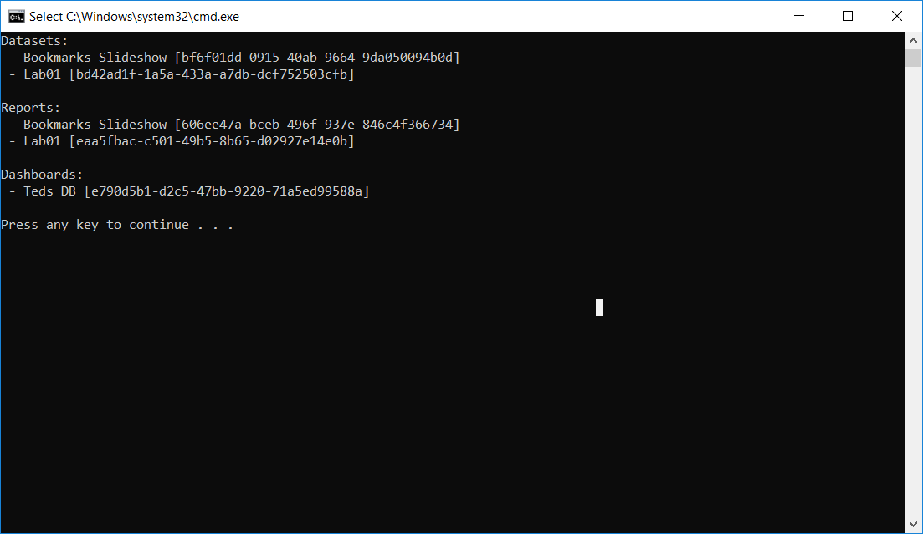

Congratulations. You have now successfully called into the Power BI Service API.